**MUSIC WEBSITE**

**MINI PROJECT**

**BACHELOR OF TECHNOLOGY**

**(COMPUTER SCIENCE & ENGINEERING)**



**VEER BAHADUR SINGH PURVANCHAL UNIVERSITY,**

**JAUNPUR**

Under the Supervision of

**Mr. Ashok Kumar Yadav**

(Assi. Professor of C.S.E.)

**Submitted By:**

Abhay (205502)

Abhishek Gautam (205505)

Sooraj Pratap (2055072)



**DEPARTMENT OF COMPUTER SCIENCE & ENGINEERING UNSIET VBSPU JAUNPUR**

**ABSTRACT**

This project is about the mp3 music player website development using website. The biggest difference between the music player and existing website is that it is completely free for users to use. It will integrate the advantages of existing music players on the market, as far as possible to mining out the existing music players' function, and then do the filtering in order to eliminate function that not practical or low cost-effective. Also, it will be keep improved based on user feedback. In addition, depending on the user's usage scenario, the music player will also add some modes, such as driving mode and night mode, to allow users to use the application in any situation or environment. Moreover, the music player will have audio trim features, allowing users to trim the best part of their favourite song into phone ringtone or alarm. On the other hand, the existing music players pay less attention to the control of gestures. Therefore, the music player will solve the limitation by adding more gestures and shake the phone feature for media control to make it more user-friendly and humanity. In a nutshell, the methodology for developing the mp3 music application used in this project is the agile development cycle. The agile development cycle consists of six phases, which is requirements analysis, planning, design, implementation or development, testing, and deployment. Due to the iterative and flexible nature of this approach, it is able to effectively adapt to users with changing requirements.

**ACKNOWLEDGEMENT**

The Lord has been faithful in granting the strength, wisdom, knowledge and the courage needed throughout this period of study. I thank the Almighty God and Father above, for life and success of this study.

I wish to show immense appreciation to our supervisor**, MR. Ashok Kumar Yadav** & **MR. Santosh Kumar** Yadav who executed his duties of supervising this work in a passionate, and an expeditious manner. My heartfelt gratitude goes to my parents, siblings and loved ones for their support in diverse forms. My sincere appreciation goes to my good friends as well as my course mates.

GOD BLESS YOU ALL.

**TABLE OF CONTENT**

SERIAL NO- CONTENT PAGE NO-

CHAPTER 1 INTRODUCTION

CHAPTER 2 PROBLEM FORMULATION & PRAPOSED WORK

2.1– PROBLEM DEFINITION

2.2– OBJECTIVES

2.3– WORKING

2.1.1 PLAY

2.1.2 PAUSE

2.1.3 NEXT

2.1.4 BACK

2.1.5 LOGIN PAGE

CHAPTER 3 METHODOLOGY

3.1 – IMPLEMENTATION STRATEGY

(FLOWCHART, ALGORITHMS ETC.)

* 1. – TOOLS/HARDWARE/SOFTWARES TO

BE USED

3.3 - PROJECT MODULE

3.3 - EXPECTED OUTCOME

(PERFORMANCE METRICS WITH DETAIL.)

CHAPTER 4 CONCLUSION

CHAPTER 5 REFERENCES

**LIST OF FIGURES**

|  |  |  |
| --- | --- | --- |
| FIGURE NO | NAME OF FIGURE | PAGE NO |
| 3.1 | Visual Studio Code |  |
| 3.2 | Html |  |
| 3.3 | CSS |  |
| 3.4 | JavaScript |  |
| 3.5 | PHP |  |
| 3.6 | Homepage of Music Band Player |  |
| 3.7 | Search page of Music Band Player |  |
| 3.8 | Music playback control interface |  |
| 3.9 | Activity Diagram |  |
| 4.1 | Site Map |  |
| 4.2 | Playlists |  |

**INTRODUCTION**

Due to the fierce competition between music player applications, many developers tried to add many features, advertise and content to their respective music player in order to retain their users and attract new users. This trend has made it harder for users to get content from their music player, which also means it's harder to filter the content that they want. With the continuous iteration of application and a growing number of features, the music player will become even more bloated and the user's experience will become less smooth. Based on Mehul (2018), users tend to feel frustrated and angry if they take a long time to get a reply from the mobile application, so they will never return to the same application, and 48% of users will simply uninstall or stop using it.

Most music player apps use touch buttons to play, pause and switch between previous and next songs while ignoring the convenience of using gesture swiping to control the music player. For instance, when a user is working and intends to skip to the next song in the music player, he/she have to switch their attention to the console from work and click the button. This problem does not affect music player properly work, but it does have some inconvenience. However, according to Sciacca (2023) said that as our physical devices and appliances develop the button-free design, consumers will become more comfortable and confident in this way of interaction, so we should consider using gesture control on more mobile applications.

When users continuously to add new songs into the playlist, the difficulty of the songs the user wants to filter will increase. After the songs in the playlist are added to reach hundreds of songs, the user can only search song by continuously swipe up or down. If not carefully check the content, it is possible to miss the songs that the user wants to filter, and then repeat the behaviour until the result is found. Therefore, it is an extremely poor experience for users

**PROBLEM FORMULATION & PRAPOSED WORK**

**PROBLEM DEFINITION** - The features provided by the proposed HTML, CSS, JAVASCRIPT project Music Band Player are to those which are usually available on visiting the local branch or on Web Page. features provided by the Music Band Player project includes: Provide facility to transfer of funds between two accounts.

• Use of Music Band Player brings efficiency in CRM (Customer relationship management) Music Band Player project provides facility to the customers to view balance and statements. It brings door to door services by using technology.

**2.2 OBJECTIVE -**

The objective of this thesis is to propose development of Website :-

1. **Make it with a simple feature and run smoothly**

by using this mp3 music player will make users feel comfortable and relaxed because it will pay more attention to the features commonly used by users, excluding some rarely used features that occupy a large of system processors, making the music player lightweight, simple, but also has powerful basic features.

1. **Support gesture control**

The MP3 music player will add features triggered by gestures to make it easier for users to use as well as less dependent on touch buttons. For example, a user can skip next or previous songs by simply swiping left and right on the anywhere of the screen in the playing interface.

1. **Support quick search**

The lack of a search bar in the music list is unacceptable. Therefore, the mp3 music player will use the search bar as well as fast scroll using alphabets on the right side of the screen, allowing users to quickly filter through hundreds of songs to find the ones users want to play.

**2.3– WORKING –**

The play, pause, next, and back functionality are essential features for any music player website. These features allow users to control their music listening experience and navigate through their music library with ease. Here's an explanation of how these features work:

**2.3.1– Play:** The play button initiates the playback of the selected track. When a user clicks on the play button, the music player loads the track and begins playing it. The play button may change to a pause button once the track is playing to allow the user to pause the track if needed.

**2.3.2– Pause:** The pause button allows the user to stop the playback of the currently playing track. When a user clicks on the pause button, the music player stops playing the track and remembers the current position of the track. The pause button may change to a play button once the track is paused to allow the user to resume playback.

**2.3.3– Next:** The next button allows the user to skip to the next track in their playlist or music library. When a user clicks on the next button, the music player loads the next track and begins playing it.

**2.3.4– Back:** The back button allows the user to skip back to the previous track in their playlist or music library. When a user clicks on the back button, the music player loads the previous track and begins playing it.

In a music player website, these functionalities are implemented using JavaScript and HTML5 audio element. The HTML5 audio element is used to load and play the tracks, while JavaScript is used to create event listeners and functions to control the playback of the tracks.

**METHODOLOGY**

**3.1 IMPLEMENTATION STRATEGY –**

**FLOWCHART -**

My music

Select a song

Play song

Play as driving mode

Media control with shaking

Media control with gesture

Media control with icon button

Finish action

**3.2 TOOLS/HARDWARE/SOFTWARE TO BE USED: -**

**3.2.1 INTRODUCTION –**

There are various tools, hardware, and software used in a music player website depending on the website's functionality and features. Here are some of the common ones:

* + 1. **HARDWARE –**
* Server and hosting equipment to host the website and store music files
* CDN (Content Delivery Network) to deliver music files to users quickly and efficiently
* Data storage devices (such as hard drives or cloud storage) to store music files
  + 1. **SOFTWARE –**
* Web development frameworks and programming languages such as HTML, CSS, JavaScript.
* Audio codec for playing music files on the website.
* Audio player libraries such as Wavesurfer.js or Player for implementing the music player functionality
* Database management systems such as MySQL or MongoDB to store user data and preferences
* Content management systems such as WordPress or Drupal for managing website content and updates
* Digital rights management (DRM) software for protecting copyrighted music conte
  + 1. **TOOLS –**

**VISUAL STUDIO CODE -**

Microsoft has released Visual Studio 2019 in early 2019. VS 2019 allows you to code in different programming languages and different platforms, Visual Basic 2019 is one of them. Visual Basic 2019 is the latest version VB.NET programming language released by Microsoft.

**Fig. 3.1: Visual Studio Code**

**3.3 PROJECT MODULE –**

1. **Html –** HTML stands for Hypertext Markup Language. It is a markup language used for creating web pages and other information that can be displayed in a web browser. HTML consists of a series of tags that describe the content and structure of a web page. These tags are enclosed in angle brackets, such as "<html>" and "</html>", and are used to specify headings, paragraphs, images, links, tables, and other elements that make up a web page.

**Fig. 3.2: Html**

**2**. **CSS –** CSS stands for Cascading Style Sheets, which is a style sheet language used for describing the presentation of a document written in HTML (or XML). CSS is used to define the look and feel of a web page, including the layout, fonts, colour, and other visual elements.

CSS allows web developers to separate the content of a web page from its presentation, which makes it easier to maintain and update the site. Instead of specifying the visual styles for each element of a web page directly in the HTML code, CSS provides a way to define these styles in a separate file, which can then be linked to the HTML file using the <link> tag.

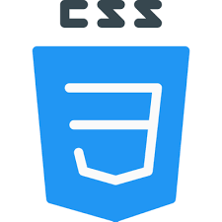

**Fig. 3.3: CSS**

**3. JavaScript-** JavaScript is a programming language that is used to create dynamic and interactive web pages. It is commonly used for client-side scripting, which means that the JavaScript code runs in the web browser of the user, rather than on a server.

JavaScript can be used to add functionality to a web page, such as validating user input, manipulating the DOM (Document Object Model), creating animations and visual effects, and communicating with servers using AJAX (Asynchronous JavaScript and XML) requests.



**Fig. 3.4: JavaScript**

**3.4 EXPECTED OUTCOME -**

**( PERFORMANCE METRICS WITH DETAIL ):**

* User Engagement: Measure the level of engagement users have with the website, including time spent on the site, pages visited, and actions taken.
* User Retention: Track the number of users who return to the website after their initial visit, as well as the frequency of their visits.
* User Satisfaction: Measure user satisfaction through surveys, feedback forms, or reviews. This can help identify areas for improvement and provide insight into what users like about the website.
* Conversion Rates: Measure the number of users who sign up for a premium account or make a purchase on the website. This can help evaluate the effectiveness of marketing campaigns and user acquisition strategies.
* Website Performance: Monitor website speed and uptime to ensure that the website is functioning optimally and is accessible to users at all times.
* Ad Performance: If the website includes advertisements, measure the click-through rate, viewability, and overall performance of ads to evaluate their effectiveness.
* Technical Performance: Monitor the website's technical performance, including server response time, database performance, and error rates, to identify and resolve any technical issues that may impact user experience.
* Content Performance: Analyze the popularity of different genres, artists, and playlists to identify trends and preferences among users. This can inform content creation and curation strategies.

The user starts the application and then it will go to the home page which is the "My music" page. The application will read the device's local songs and generate a playlist. After that, the user selects the song and plays it, the page will jump into the playing music interface, where the user is allowed to control the music. Playing modes are allowed to control music play orders which are shuffle playback, single cycle, and normal playback. Moreover, the user can also skip to the next song, back to the previous song and play or pause the current music to control music. Lastly, the user can enable the driver mode to play the song.

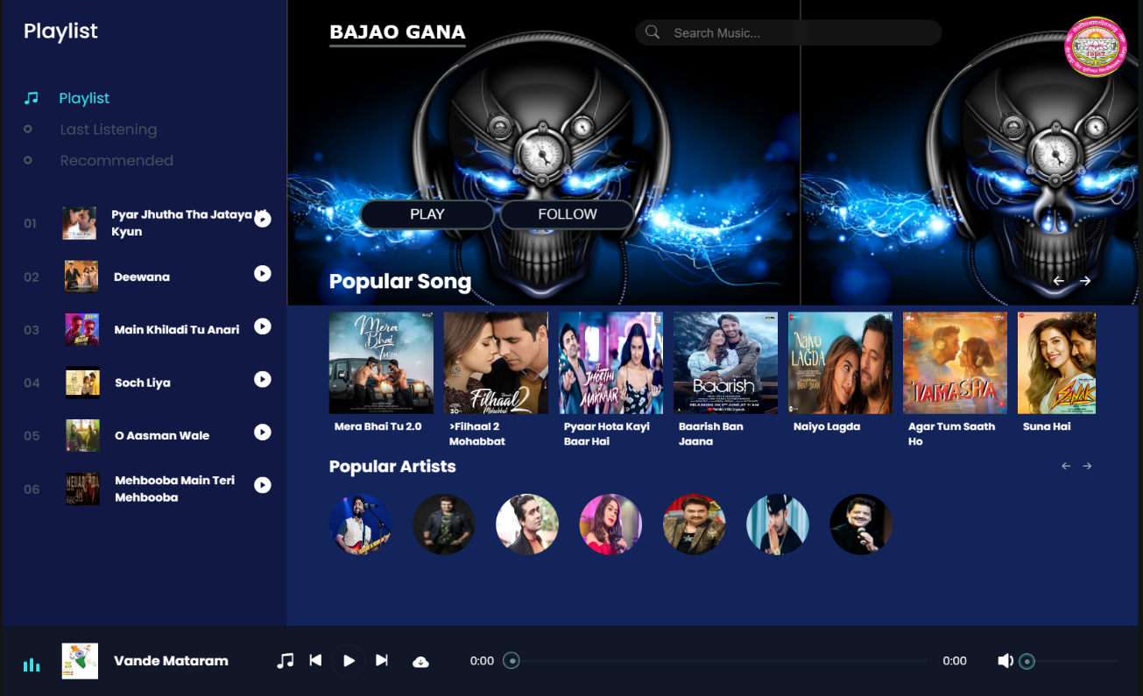

**CONCLUSION**

## 4.1 Project Review, Discussions and Conclusion

In a nutshell, when users hold the mentality of venting and relaxation to expect the music player to bring them relief pressure, in result the application with a dazzling and complex interface, a variety of multifarious functions, from time to time prompt out of the advertising, as well as the function that requires be a members to use, which will only make users feel more depressed and feel the pressure.

Moreover, most people who use a music player, usually don't leave the music player open in the foreground, but start playing music and then go on to do something else at hand such as take a break, read a book and news, or play a game. As a result, they can't focus on the various functions and buttons in the app's interface. For instance, users who are lying down to take a break and tried to switch to the next song but they need lots of action like unlocking the phone, open the app again in the background and look for the switch button.

In addition, the specific song is overwhelmed by a large number of songs and cause information overload, users can only spend more energy and time to find it. For example, searching for a book in the library, and realize that there is no library catalog is mean to looking for a needle in a haystack.

In short, the proposed application will combine the strengths of most music players on the existing market and eliminate some unrealistic features, allowing users to focus on listening to music rather than store, communities or various VIP packages or features. The proposed MP3 music player will focus on improving the experience of users of the music player experience.

### **4.2. Project Achievement**

Firstly, the proposed music player had achieved its first objective, which is to make the music player become a simple, easy-to-use, and well-run application. The proposed application had become faster startup, smaller size, and less memory usage by eliminating some unrealistic features. The application also adding some useful features like audio trim.

Next, the proposed music player achieves a second objective which is to reduce the use of button controls and enhance the way the app interacts with the user, such as using gestures and shaking controls. Using gestures, the user doesn't have to pay full attention to the phone, but simply swipes right or left at any place in the playing interface to switch the songs. In addition, if the app is running on the lock screen or in the background, users can successfully switch to the next song by simply shaking the phone, completely eliminating the use of buttons.

Lastly, the proposed music player achieves a third objective which is a quick search. The application will use the search bar and the alphabet fast scroll, allowing users to quickly traverse the song playlist and find the songs they want, which is an efficient way. For example, if a user wants to search the playlist for a song called "Lemon", he or she just enters a character that is 'm' into the search bar and the result appears. This is because the name of the song contains the characters entered in the search bar.

### **4.3.Problem Encountered**

The main problem encounter in this project is the structure of code which the structure no build well at first and led to keep modification during developing night mode. Since the layout interface of each activity is not build as uniformly managed and updated at the beginning, only one layout is updated to the dark color after the night mode is enabled, and the layout of the other remains unchanged. Fortunately, these problems were solved in the final development stage, but the solution is informal and no efficiently, as it is achieved by using a lot of duplicate coding to solve.

## 4.4. Future Work

1. Enhanced interactivity, allowing users to open song playlist when they swipe up from the music playing interface
2. Implement of the in-app download of songs, rather than the current use of a specific website as a hyperlink
3. Refactoring code, rebuild the coding structure to make the coding look cleaner, easier to understand and perform efficiently
4. Cross-platform, running the app on IOS, not only Android

**REFERENCE**

Guru99.com. (2019). *Mobile App Performance Testing: CheckList, Tools (Andriod & iOS)*. [online] Available at: https://www.guru99.com/mobile-app-performance-testingstrategy-tools.html#1 [Accessed 15 Jul. 2019].

Joox.com. (2019). *JOOX - Music Anytime Anywhere.* [online] Available at: https://www.joox.com/my-en [Accessed 28 Jun. 2019].

Kr-asia.com. (2019). *Spotify facing growth pains in Asia, where Tencent’s Joox is more popular – KrASIA*. [online] Available at: https://kr-asia.com/spotify-facing-growthissue-in-asia-where-tencents-joox-is-more-popular [Accessed 29 Jun. 2019].

Mehul, R. (2018). *Top Reasons Why Your Mobile App is Slow and How to Fix it*. [online] Available at: https://www.freecodecamp.org/news/top-reasons-why-your-mobile-appis-slow-and-how-to-fix-it-f0f7ce524934/ [Accessed 19 Mar. 2020].

Play.google.com. (2019). [online] Available at: https://play.google.com/store/apps/details?id=com.gugu.music&hl=en [Accessed 25 Jun. 2019].

Play.google.com. (2019). [online] Available at: https://play.google.com/store/apps/details?id=fm.xiami.main&hl=en [Accessed 26 Jun.

2019].

Sohail, A. (2019). *Agile Project Management: Understanding and Benefits - DevCrew I/O. [online] DevCrew I/O*. Available at: https://devcrew.io/2017/08/03/agile-basics/ [Accessed 17 Jul. 2019].

BIS (Hons) Information Systems Engineering

Faculty of Information and Communication Technology (Kampar Campus), UTAR.

Scacca, S. (2020). *When to Design with Gestures vs. Buttons*. [online] Available at: https://www.telerik.com/blogs/when-to-design-with-gestures-vs-buttons [Accessed 19 Mar. 2020].